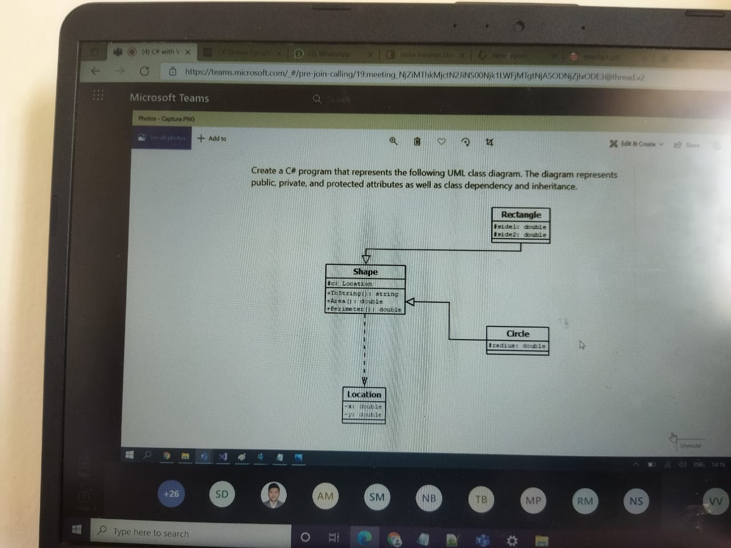

using System;

namespace ConsoleApp6

{

class Shape

{

public double Area()

{

return 0;

}

public double Perimeter()

{

return 0;

}

}

class Rectangle : Shape

{

double side1, side2;

public Rectangle(double side1, double side2)

{

this.side1 = side1;

this.side2 = side2;

}

public double Area()

{

return side1 \* side2;

}

public double Perimeter()

{

return (2 \* (side1 + side2));

}

}

class Circle : Shape

{

double radius;

public Circle(double radius)

{

this.radius = radius;

}

public double Area()

{

return ((22 / 7) \* (radius \* radius));

}

public double Perimeter()

{

return (2 \* (22 / 7) \* radius);

}

}

class Class11

{

public static void Main()

{

Rectangle r = new Rectangle(3.5, 2.5);

Console.WriteLine("Area of rectangle:" + r.Area());

Console.WriteLine("Perimeter of rectangle:" + r.Perimeter());

Console.WriteLine();

Circle c = new Circle(2.5);

Console.WriteLine("Area of Circle is: " + c.Area());

Console.WriteLine("Perimeter of Circle is: " + c.Perimeter());

Console.ReadLine();

}

}

}